Recommending Products Using Cloud SQL and Spark

1 hour 30 minutesFree

Rate Lab

**Overview**

In this lab, you populate rentals data in Cloud SQL for the rentals recommendation engine to use. The recommendations engine itself will run on Dataproc using Spark ML.

Objectives

In this lab, you learn how to perform the following tasks:

* Create a Cloud SQL instance
* Create database tables by importing .sql files from Cloud Storage
* Populate the tables by importing .csv files from Cloud Storage
* Allow access to Cloud SQL
* Explore the rentals data using SQL statements from Cloud Shell

**Set up your environments**

Check project permissions

Before you begin your work on Google Cloud, you need to ensure that your project has the correct permissions within Identity and Access Management (IAM).

1. In the Google Cloud console, on the **Navigation menu** (), click **IAM & Admin** > **IAM**.
2. Confirm that the default compute Service Account {project-number}-compute@developer.gserviceaccount.com is present and has the editor role assigned. The account prefix is the project number, which you can find on **Navigation menu** > **Home**.

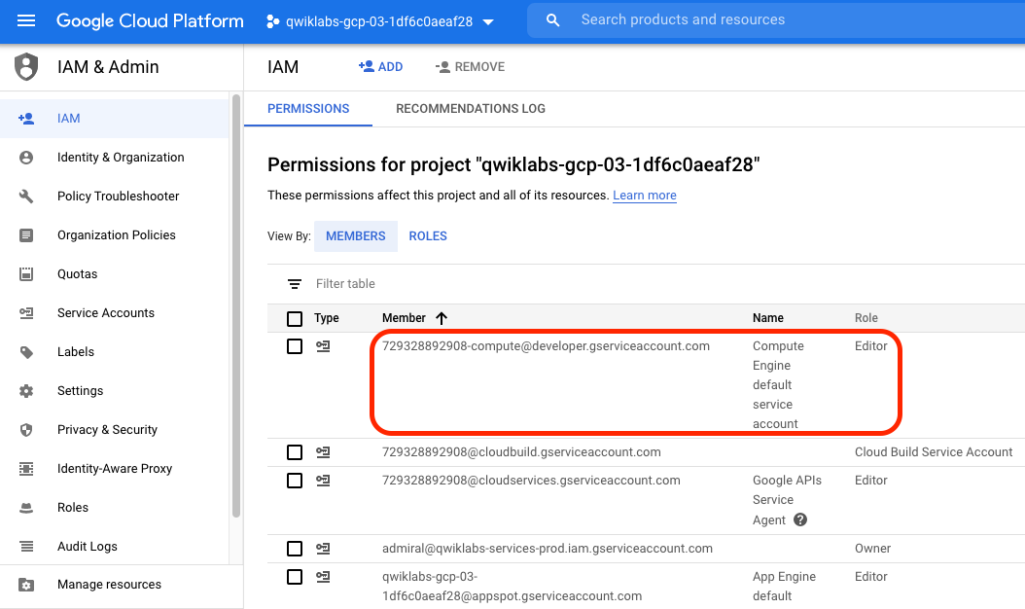

If the account is not present in IAM or does not have the editor role, follow the steps below to assign the required role.

* In the Google Cloud console, on the **Navigation menu**, click **Home**.
* Copy the project number (e.g. 729328892908).
* On the **Navigation menu**, click **IAM & Admin** > **IAM**.
* At the top of the **IAM** page, click **Add**.
* For **New members**, type:

{project-number}-compute@developer.gserviceaccount.com

content_copy

Replace {project-number} with your project number.

* For **Role**, select **Project** > **Editor**. Click **Save**.

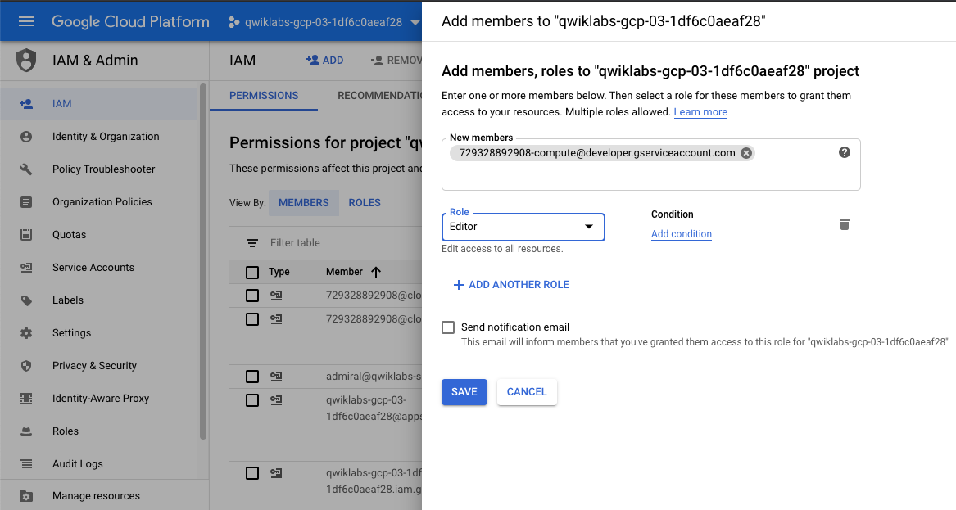

**Task 1. Create a Cloud SQL instance**

1. In the Google Cloud Console, Select **Navigation menu > SQL** (in the Storage section).
2. Click **Create instance**.
3. Click **Choose MySQL**.
4. For **Instance ID**, type **rentals**.

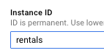

1. Scroll down and specify a **Root password**. Before you forget, note down the root password.
2. Click **Create** to create the instance. It will take a minute or so for your Cloud SQL instance to be provisioned.

**Task 2. Create tables**

1. While you wait for your instance to be created, read the below mySQL script and answer the questions that follow.

CREATE DATABASE IF NOT EXISTS recommendation_spark;

USE recommendation_spark;

DROP TABLE IF EXISTS Recommendation;

DROP TABLE IF EXISTS Rating;

DROP TABLE IF EXISTS Accommodation;

CREATE TABLE IF NOT EXISTS Accommodation

(

id varchar(255),

title varchar(255),

location varchar(255),

price int,

rooms int,

rating float,

type varchar(255),

PRIMARY KEY (ID)

);

CREATE TABLE IF NOT EXISTS Rating

(

userId varchar(255),

accoId varchar(255),

rating int,

PRIMARY KEY(accoId, userId),

FOREIGN KEY (accoId)

REFERENCES Accommodation(id)

);

CREATE TABLE IF NOT EXISTS Recommendation

(

userId varchar(255),

accoId varchar(255),

prediction float,

PRIMARY KEY(userId, accoId),

FOREIGN KEY (accoId)

REFERENCES Accommodation(id)

);

SHOW DATABASES;content_copy

How many tables will this script create?



3



2



1

Submit

When a user rates a house (giving it four stars for example), an entry is added to the _______ table.



Recommendation



Rating



Accommodation

Submit

General information about houses, such as the number of rooms they have and their average rating is stored in the _________ table.



Recommendation



Rating



Accommodation

Submit

The job of the recommendation engine is to fill out the ___________ table for each user and house: this is the predicted rating of that house by that user.



Recommendation



Rating



Accommodation

Submit

1. In **Cloud SQL**, click **rentals** to view instance information.

Connect to the database

1. Find the **Connect to this instance** box on the page and click on **connect using Cloud Shell**.

**Note:** You could also connect to your instance from a dedicated Cloud Compute Engine VM but for now you'll have Cloud Shell create a micro-VM for you and operate from there.

1. If required, click **Continue**. Wait for Cloud Shell to load.
2. Once Cloud Shell loads, you will see the below command already typed:

* gcloud sql connect rentals --user=root --quiet

1. Press **ENTER**.
2. Wait for your IP Address to be whitelisted.

Allowlisting your IP for incoming connection for 5 minutes...⠹

content_copy

1. When prompted, enter your password and press **ENTER** (note: you will not see your password typed in or even ****).

You can now run commands against your database! 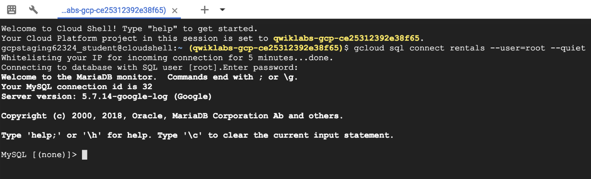

1. Run the following command:

SHOW DATABASES;content_copy

You should see the default system databases:

+--------------------+

| Database |

+--------------------+

| information_schema |

| mysql |

| performance_schema |

| sys |

+--------------------+

content_copy

**Note:** You must always end your mySQL commands with a semi-colon `;`

1. Copy and paste the below SQL statement you analyzed earlier into the command line.

CREATE DATABASE IF NOT EXISTS recommendation_spark;

USE recommendation_spark;

DROP TABLE IF EXISTS Recommendation;

DROP TABLE IF EXISTS Rating;

DROP TABLE IF EXISTS Accommodation;

CREATE TABLE IF NOT EXISTS Accommodation

(

id varchar(255),

title varchar(255),

location varchar(255),

price int,

rooms int,

rating float,

type varchar(255),

PRIMARY KEY (ID)

);

CREATE TABLE IF NOT EXISTS Rating

(

userId varchar(255),

accoId varchar(255),

rating int,

PRIMARY KEY(accoId, userId),

FOREIGN KEY (accoId)

REFERENCES Accommodation(id)

);

CREATE TABLE IF NOT EXISTS Recommendation

(

userId varchar(255),

accoId varchar(255),

prediction float,

PRIMARY KEY(userId, accoId),

FOREIGN KEY (accoId)

REFERENCES Accommodation(id)

);

SHOW DATABASES;content_copy

1. Press **ENTER**.
2. Confirm that you now see recommendation_spark as a database:

+----------------------+

| Database |

+----------------------+

| information_schema |

| mysql |

| performance_schema |

| recommendation_spark |

| sys |

+----------------------+

content_copy

1. Run the following command to show the tables:

USE recommendation_spark;

SHOW TABLES;content_copy

1. Press **ENTER**.
2. Confirm that you see the three tables:

+--------------------------------+

| Tables_in_recommendation_spark |

+--------------------------------+

| Accommodation |

| Rating |

| Recommendation |

+--------------------------------+

content_copy

1. Run the following query:

SELECT * FROM Accommodation;content_copy

How many rows are in the Accommodation table?



Empty set (0)



100



1,000

Submit

**Task 3. Stage data in Cloud Storage**

Option 1: Use the command line

1. Open a new Cloud Shell tab **(do not use your existing mySQL Cloud Shell tab)**.
2. Copy and paste the following command:

echo "Creating bucket: gs://$DEVSHELL_PROJECT_ID"

gsutil mb gs://$DEVSHELL_PROJECT_ID

echo "Copying data to our storage from public dataset"

gsutil cp gs://cloud-training/bdml/v2.0/data/accommodation.csv gs://$DEVSHELL_PROJECT_ID

gsutil cp gs://cloud-training/bdml/v2.0/data/rating.csv gs://$DEVSHELL_PROJECT_ID

echo "Show the files in our bucket"

gsutil ls gs://$DEVSHELL_PROJECT_ID

echo "View some sample data"

gsutil cat gs://$DEVSHELL_PROJECT_ID/accommodation.csvcontent_copy

1. Press **ENTER**.

Option 2: Use the Cloud Console UI

*Skip these steps if you have already loaded your data using the command line.*

1. Navigate to **Storage** and select **Storage > Browser**.
2. Click **Create Bucket** (if one does not already exist).
3. Specify your project name as the bucket name.
4. Click **Create**.
5. Download the below files locally and then upload them inside of your new bucket:

* [accommodation.csv](https://storage.googleapis.com/cloud-training/bdml/v2.0/data/accommodation.csv)
* [rating.csv](https://storage.googleapis.com/cloud-training/bdml/v2.0/data/rating.csv)

**Task 4. Load data from Cloud Storage into Cloud SQL tables**

1. Navigate back to **SQL**.
2. Click on **rentals**.

Import accommodation data

1. Click **Import** (top menu).
2. Specify the following:

* Source: Click **Browse > [Your-Bucket-Name] > accommodation.csv**

Click **Select**.

* Format of import: **CSV**
* Database: select recommendation_spark from the dropdown list
* Table: copy and paste: Accommodation

1. Click **Import**.

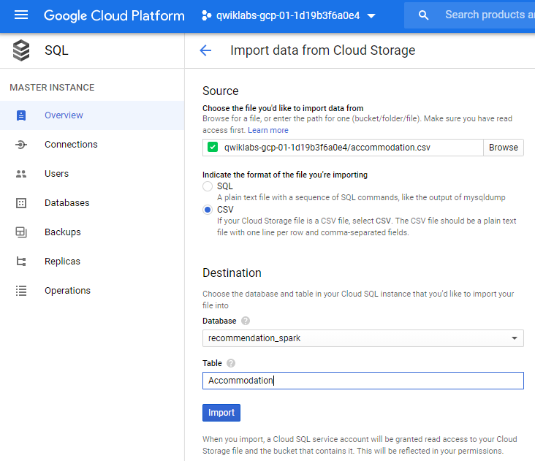

1. You will be redirected back to the Overview page. Wait one minute for the data to load.

Import user rating data

1. Click **Import** (top menu).
2. Specify the following:

* Source: Click **Browse > [Your-Bucket-Name] > rating.csv**

Click **Select**.

* Format of import: **CSV**
* Database: select recommendation_spark from the dropdown list
* Table: copy and paste: Rating

1. Click **Import**.
2. You will be redirected back to the Overview page. Wait one minute for the data to load.

**Task 5. Explore Cloud SQL data**

1. If you closed your Cloud Shell connection to mySQL, open it again by finding **Connect to this instance** and clicking **Connect using Cloud Shell**.
2. Press **ENTER** when prompted to log in.
3. Provide your password and press **ENTER**.
4. Query the ratings data:

USE recommendation_spark;

SELECT * FROM Rating

LIMIT 15;content_copy

1. Use a SQL aggregation function to count the number of rows in the table.

SELECT COUNT(*) AS num_ratings

FROM Rating;content_copy

How many ratings are in the table?



1186



100,000



5,203

Submit

1. What is the average review rating of accommodations?

SELECT

COUNT(userId) AS num_ratings,

COUNT(DISTINCT userId) AS distinct_user_ratings,

MIN(rating) AS worst_rating,

MAX(rating) AS best_rating,

AVG(rating) AS avg_rating

FROM Rating;content_copy

What is the average rating across all reviews?



4.51



5.0



2.46

Submit

What does the 25 for distinct_user_ratings mean?



There are 25 unique users who provided the ratings



There are 25 ratings per accommodation



There are 25 ratings per user

Submit

In machine learning, you will need a rich history of user preferences for the model to learn from. Run the below query to see which users have provided the most ratings.

SELECT

userId,

COUNT(rating) AS num_ratings

FROM Rating

GROUP BY userId

ORDER BY num_ratings DESC;content_copy

How many reviews did the top user leave?



50



100



75

Submit

1. Exit the mysql prompt by typing **exit**.

**Task 6. Launch Dataproc**

You use Dataproc to train the recommendations machine learning model based on users' previous ratings. You then apply that model to create a list of recommendations for every user in the database

To launch Dataproc and configure it so that each of the machines in the cluster can access Cloud SQL:

1. In the Cloud Console, on the **Navigation menu** (Navigation menu), click **SQL** and note the region of your Cloud SQL instance:



In the snapshot above, the region is us-central1.

1. In the Cloud Console, on the **Navigation menu** (Navigation menu), click **Dataproc** and click **Enable API** if prompted.
2. Once enabled, click **Create cluster** and name your cluster **rentals**.
3. Leave the **Region** as it is i.e. **us-central1** and change the **Zone** to **us-central1-a** (in the same zone as your Cloud SQL instance). This will minimize network latency between the cluster and the database.
4. For **Master node**, for **Machine type**, select **n1-standard-2 (2 vCPUs, 7.5 GB memory)**.
5. For **Worker nodes**, for **Machine type**, select **n1-standard-2 (2 vCPUs, 7.5 GB memory)**.
6. Leave all other values with their default and click **Create**. It will take 1-3 minutes to provision your cluster.
7. Note the **Name**, **Zone** and **Total worker nodes** in your cluster.
8. Copy and paste the below bash script into your Cloud Shell (optionally change CLUSTER, ZONE, NWORKERS if necessary before running)

echo "Authorizing Cloud Dataproc to connect with Cloud SQL"

CLUSTER=rentals

CLOUDSQL=rentals

ZONE=us-central1-a

NWORKERS=2

machines="$CLUSTER-m"

for w in `seq 0 $(($NWORKERS - 1))`; do

machines="$machines $CLUSTER-w-$w"

done

echo "Machines to authorize: $machines in $ZONE ... finding their IP addresses"

ips=""

for machine in $machines; do

IP_ADDRESS=$(gcloud compute instances describe $machine --zone=$ZONE --format='value(networkInterfaces.accessConfigs[].natIP)' | sed "s/\['//g" | sed "s/'\]//g" )/32

echo "IP address of $machine is $IP_ADDRESS"

if [ -z $ips ]; then

ips=$IP_ADDRESS

else

ips="$ips,$IP_ADDRESS"

fi

done

echo "Authorizing [$ips] to access cloudsql=$CLOUDSQL"

gcloud sql instances patch $CLOUDSQL --authorized-networks $ipscontent_copy

1. Press **ENTER**. When prompted, type **Y**, then press **ENTER** again to continue.
2. Wait for the patching to complete. You will see the following:

Patching Cloud SQL instance...done.

content_copy

1. On the main Cloud SQL page, under **Connect to this instance**, copy your **Public IP Address** to your clipboard. (Alternatively, write it down because you're using it next.)

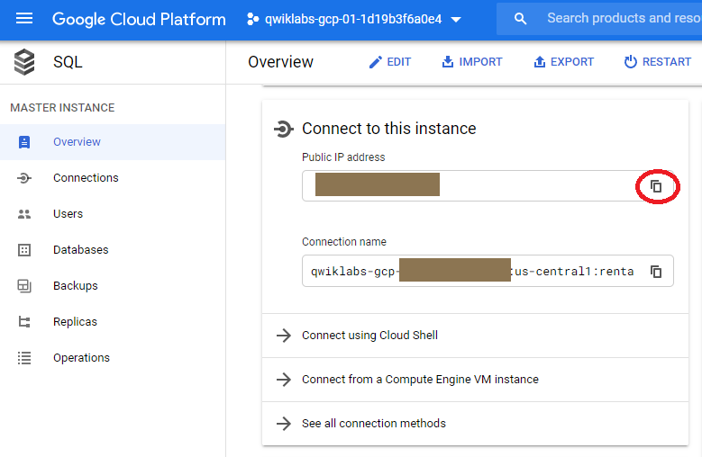

**Task 7. Run the ML model**

Next, you create a trained model and apply it to all the users in the system. Your data science team has created a recommendation model using Apache Spark and is written in Python. Copy it over into your staging bucket.

1. Copy over the model code by executing the below commands in Cloud Shell:

gsutil cp gs://cloud-training/bdml/v2.0/model/train_and_apply.py train_and_apply.py

cloudshell edit train_and_apply.pycontent_copy

1. When prompted, select **Open in New Window**.
2. Wait for the Editor UI to load.
3. Open the train_and_apply.py file, find line 30: **CLOUDSQL_INSTANCE_IP**, and paste the Cloud SQL IP address you copied earlier.

*# MAKE EDITS HERE*

CLOUDSQL_INSTANCE_IP = '<paste-your-cloud-sql-ip-here>' *# <---- CHANGE (database server IP)*

CLOUDSQL_DB_NAME = 'recommendation_spark' *# <--- leave as-is*

CLOUDSQL_USER = 'root' *# <--- leave as-is*

CLOUDSQL_PWD = '<type-your-cloud-sql-password-here>' *# <---- CHANGE*content_copy

1. Find line 33: **CLOUDSQL_PWD** and type in your Cloud SQL password,
2. The editor will autosave but to be sure, select **File > Save**.
3. From the Cloud Shell ribbon, click on the **Open Terminal** icon and copy this file to your Cloud Storage bucket using this Cloud Shell command:

gsutil cp train_and_apply.py gs://$DEVSHELL_PROJECT_IDcontent_copy

**Task 8. Run your ML job on Dataproc**

1. In the **Dataproc** console, click **rentals** cluster.
2. Click **Submit job**.
3. For **Job type**, select **PySpark** and for **Main python file**, specify the location of the Python file you uploaded to your bucket. Your <bucket-name> is likely to be your Project ID, which you can find by clicking on the Project ID dropdown in the top navigation menu.

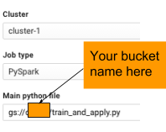

gs://<bucket-name>/train_and_apply.py

1. Click **Submit**.
2. Select **Navigation menu > Dataproc > Job** tab to see the Job status.

**Note:** It will take up to 5 minutes for the job to change from `Running` to `Succeeded`. You can continue to the next section on querying the results while the job runs. If the job `Failed`, please troubleshoot using the logs and fix the errors. You may need to re-upload the changed Python file to Cloud Storage and clone the failed job to resubmit.

**Task 9. Explore inserted rows with SQL**

1. In a new browser tab, open **SQL** (in the Storage section).
2. Click **rentals** to view details related to your Cloud SQL instance.
3. Under **Connect to this instance** section, click **Connect using Cloud Shell**. This will start a new Cloud Shell tab. In the Cloud Shell tab press **ENTER**.

It will take a few minutes to allow your IP for the incoming connection.

1. When prompted, type the root password you configured, then press **ENTER**.
2. At the mysql prompt, type:

USE recommendation_spark;

SELECT COUNT(*) AS count FROM Recommendation;content_copy

If you are getting an Empty Set (0) - wait for your Dataproc job to complete. If it's been more than 5 minutes, your job has likely failed and will require troubleshooting.

Tip: You can use the up arrow in Cloud Shell to return your previous command (or query in this case)

How many recommendations did the model provide?



100



125



50

Submit

1. Find the recommendations for a user:

SELECT

r.userid,

r.accoid,

r.prediction,

a.title,

a.location,

a.price,

a.rooms,

a.rating,

a.type

FROM Recommendation as r

JOIN Accommodation as a

ON r.accoid = a.id

WHERE r.userid = 10;content_copy

1. Your result should be similar to the below result:

+--------+--------+------------+-----------------------------+...

| userid | accoid | prediction | title |...

+--------+--------+------------+-----------------------------+...

| 10 | 41 | 1.7748766 | Big Calm Manor |...

| 10 | 21 | 1.7174504 | Big Peaceful Cabin |...

| 10 | 46 | 1.7159091 | Colossal Private Castle |...

| 10 | 31 | 1.5783813 | Colossal Private Castle |...

| 10 | 32 | 1.5584077 | Immense Private Hall |...

+--------+--------+------------+-----------------------------+...

content_copy

These are the five accommodations that you would recommend. Note that the quality of the recommendations is not great because the dataset was so small (note that the predicted ratings are not very high). Still, this lab illustrates the process you'd go through to create product recommendations.

Congratulations!

You have populated rentals data in Cloud SQL for the rentals recommendation engine to use.

Recap:

In this lab, you:

* Created a fully-managed Cloud SQL instance for rentals
* Created tables and explored the schema with SQL
* Ingested data from CSVs
* Edited and ran a Spark ML job on Dataproc
* Viewed prediction results